You are all the nudes in history

Blow and suck your publics and your privates

Wombs on the rise

It is not man returning to his own vomit nor is it an allocation of sign but purely the idea of idea

Fur coat and a line of fire
Fur coat is draped from a hook that hangs from the sealing
There are writings on the wall

Relational aesthetics
Rules change in time of social change brought about in changes in economics
Or the dend to a postmodernist governmental system
A eulogy t the past decade of decedent art

The fur coat represents what is bourgouse what is avant garde and what is indvidual- and individual which is at the center of a post modernists socity

In a search for a new language to faccilate a change
A new way of bringing about change
And e

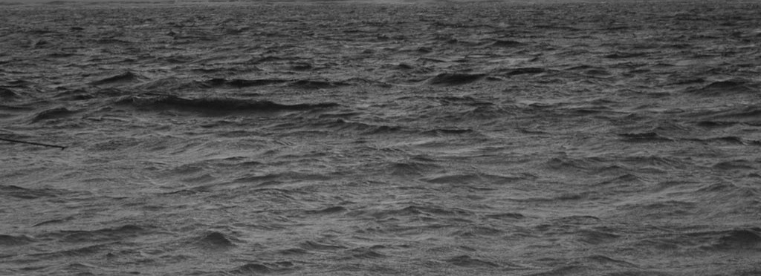

Dear Sir or madam

I have been unable to track down my password and user name in order to apply for funding this year
My sass reference number, which i found on my original letter from sass back in 2006
Which is
55124127
Does not seem to be operational
I have tried contacting sass by phone about the matter, but have been unable to get through to talk to someone as i receive instead a network busy response on my mobile and a forced end to the call.
Would it be possible to send an updated user name and password and confirm my student reference number?
Thank you very much for your time

Kind regards

